SIMM (Single In Line Memory Module)

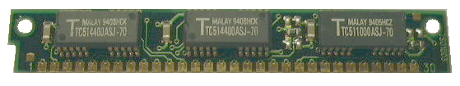

Pin1

SIMM 8 Bit (+ 1Parity Bit) Busbreite maximal 16MegaByte

Pin | Signal
1 | VCC (+5V)
2 | /CAS (Column Address Strobe)
3 | D0
4 | A0
5 | A1
6 | D1
7 | A2
8 | A3
9 | GND
10 | D2
11 | A4
12 | A5
13 | D3
14 | A6
15 | A7
16 | D4
17 | A8
18 | A9
19 | A10
20 | D5
21 | /WE (Write Enable)
22 | GND
23 | D6
24 | NC oder A11
25 | D7
26 | D8 Out Parity
27 | /RAS
28 | /CAS Parity (Column Address Strobe Parity)
29 | D8 In Parity
30 | VCC (+5V)

